John Shanrock, Joshua Smith

February 27, 2017

Laboratory 3: Active Current Sources

**Objective**

Many linear integrated circuit designs require a current source. For example, an independent current source is frequently used in the production of a differential amplifier since it is undesirable to fabricate large resistors on an IC. The goal of this lab is to design a two-transistor current source and a Widlar current source. This design requires calculating the resistors values based on the desired output current within a voltage range.

**Design Calculations**

For the first part of this lab, we designed the simple current source shown in Figure 1. We desired to build a circuit such that IC=IL=2.5mA±5% utilizing VCC=10V. We assumed that VBE(on)=0.7V.

$$R_{C}=\frac{V_{CC}-V_{BE}(on)}{I_{C}}=\frac{10-0.7}{0.0025}=3720Ω$$

$$R_{L}=\frac{V_{CC}-V_{O}}{I_{L}}=\frac{10-6}{0.0025}=1600Ω$$

For the second part of this lab, we designed a Widlar current source shown in Figure 2. We desired to build a circuit such that over the output voltage range 3-7V the output current should meet the specification IO=100±20μA assuming IC=10mA and RE=1197Ω.

$$R_{C}=\frac{V_{CC}-V_{BE}(on)}{I_{C}}=\frac{10-0.7}{0.01}=930Ω$$

$$R_{L}=\frac{V_{CC}-V_{O}}{I_{L}}=\frac{10-7}{0.0001}=30kΩ$$

The calculated resistor values are summarized in Table 1. The experimental voltages are summarized in Table 2. The input and output currents were calculated using Ohm’s Law and the values provided in Table 1 and Table 2. These results are summarized in Table 3.

**Conclusions**

The LT-SPICE schematics shown in Figure 3 and Figure 4 represent the current sources shown in Figure 1 and Figure 2 respectively. These schematics were developed using the calculated resistor values summarized in Table 1. The expected theoretical voltages across RC, RL, VO, and RE respectively are shown to the left of each schematic in Figure 3 and Figure 4. These voltages were compared to the experimental voltages shown in Table 2; the small differences in values here were assumed to be due to the tolerance of the devices used, but the experimental voltages values measured were as expected. The currents in Table 3 approximately match the desired currents as specified by the design specification.

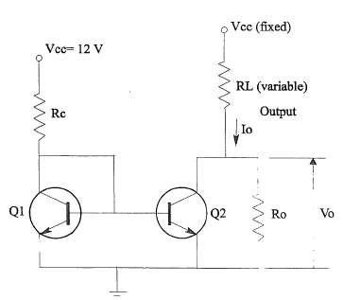

**Figure 1 – Simple Current Source**

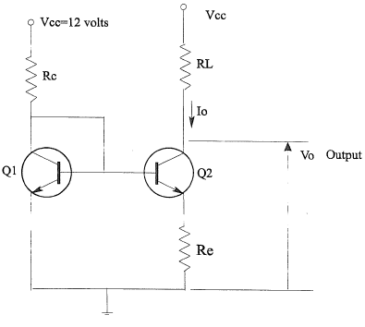

**Figure 2 – Widlar Current Source**

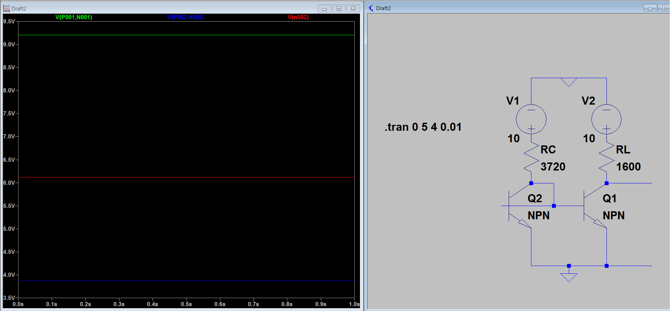**Figure 3 – Basic Current Source**

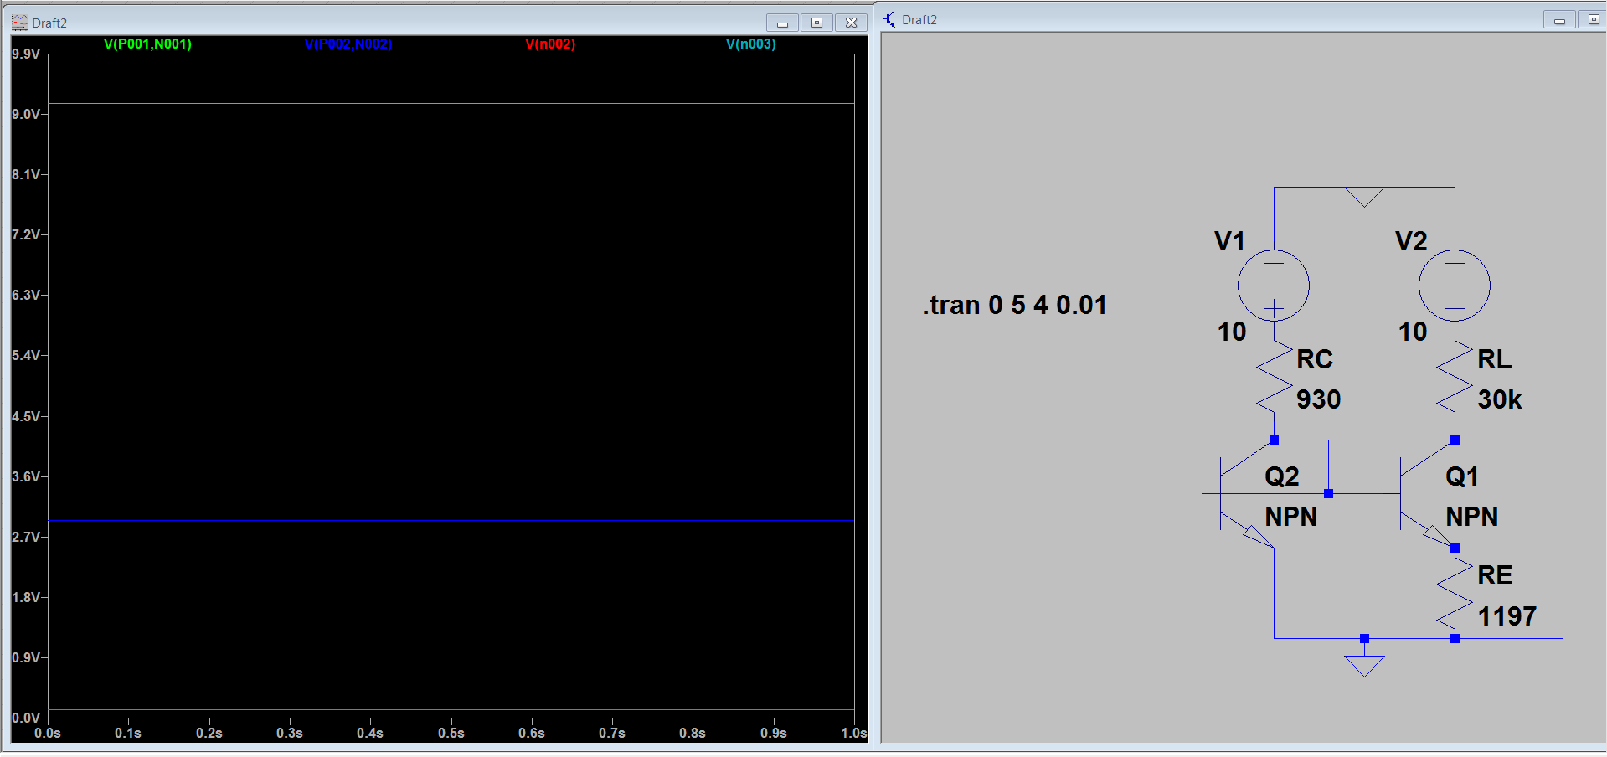

**Figure 4 – Widlar Current Source**

**Table 1 – Resistor Values (Ω)**

|  |  |  |
| --- | --- | --- |
|  | **Figure 1** | **Figure 2** |
| **RC** | 3720 | 930 |
| **RL** | 1600 | 30k |
| **RE** | **-** | 1197 |

**Table 2 – Voltage Results (V)**

|  |  |  |
| --- | --- | --- |
|  | **Figure 1** | **Figure 2** |
| **RC** | 9.2321 | 9.2338 |
| **RL** | 4.0386 | 2.3979 |
| **VO** | 5.9440 | 7.5635 |
| **RE** | **-** | 0.10111 |

**Table 3 – Calculated Results (mA)**

|  |  |  |
| --- | --- | --- |
|  | **Figure 1** | **Figure 2** |
| **Input Current** | 2.4817 | 9.9288 |
| **Output Current** | 2.5243 | 0.07993 |